**8.Arduino UNO platform -------** **light_follow**

1. **Preparation**

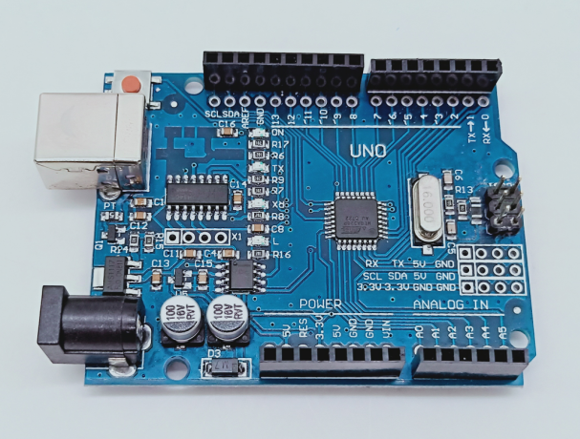

1-1 Arduino UNO board

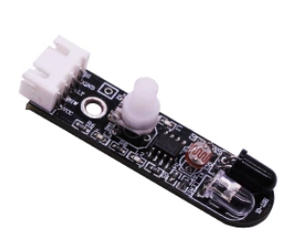

1-2 Infrared obstacle avoidance module

**2)Purpose of Experimental**

After the code upload is completed, you need to press the K2 to start the car, and the light follow function is started. When both light-sensitive resistors detect light, the car advance; when there is light detected on the left side, the car turn left; when light is detected on the right side, the car turn right; when no light is detected on the left and right sides, the car stopped.

**3)Principle of experimental**

The photoresistor is a resistor made by utilizing the photoconductivity of the semiconductor to change the resistance value according to the intensity of the incident light. The incident light intensity, the resistance is reduced, the incident light is weak, and the resistance is increased. If there is light, the level of the pin connected to the photoresistor becomes high level.

**4)Experimental Steps**

4-1 About the schematic

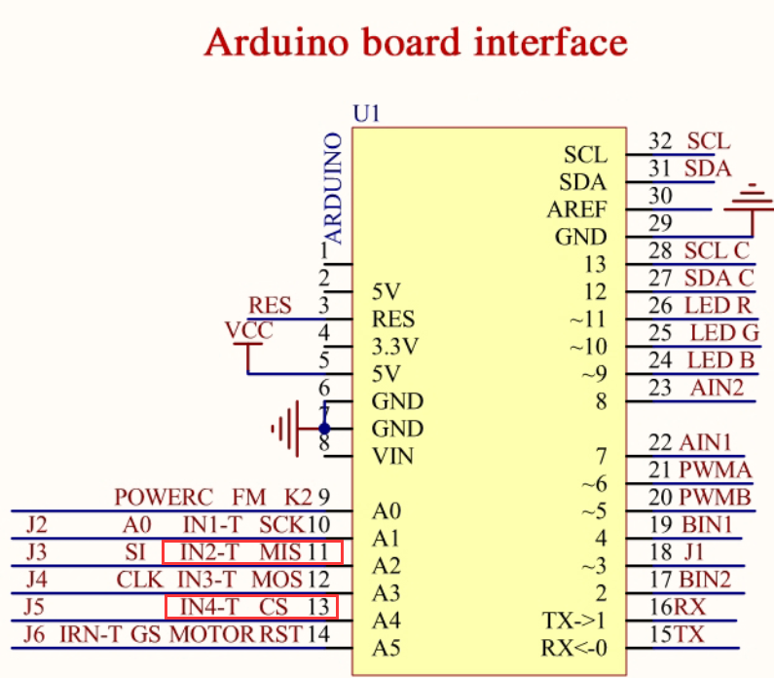

4-1 Arduino UNO interface circuit diagram

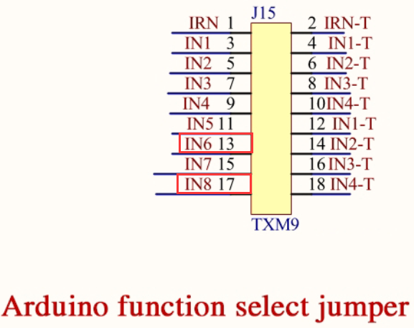

4-2 Arduino function select jumper

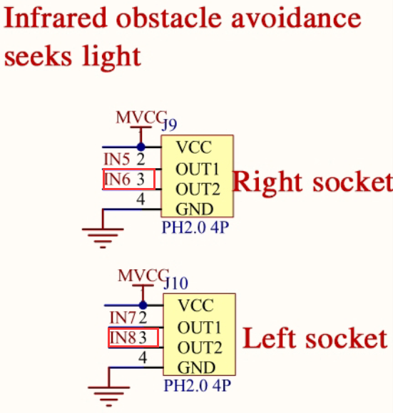

4-3 Left and right infrared sensor interface

4-2 According to the circuit schematic:

Left infrared sensor----- A4

Right infrared sensor-----A2

(Note: We use the wiringPi library to write code.)

（Note: In this experiment, we can adjust the sensitivity of the light follow module by rotating the potentiometer on the infrared module to achieve better experimental results.）

4-3 About the code

1. We need to open the code of this experiment:**light_follow.ino**, click“**√**” under the menu bar to compile the code, and wait for the word "**Done compiling** " in the lower right corner, as shown in the figure below.

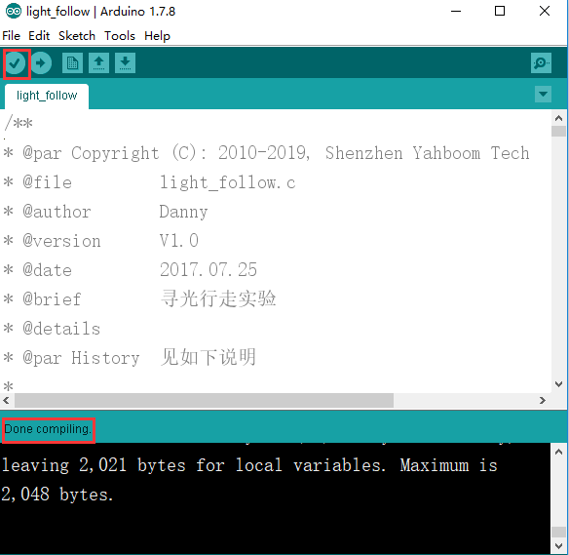

2.In the menu bar of Arduino IDE, we need to select 【Tools】---【Port】--- selecting the port that the serial number displayed by the device manager just now, as shown in the figure below.

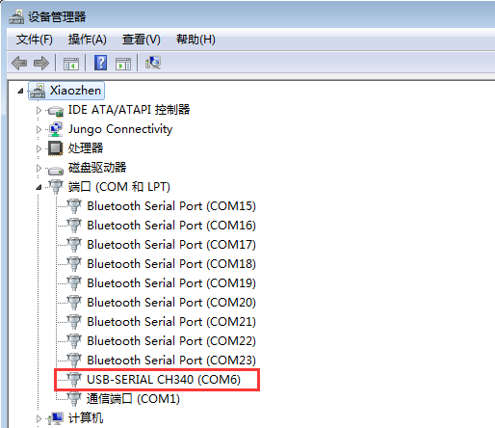

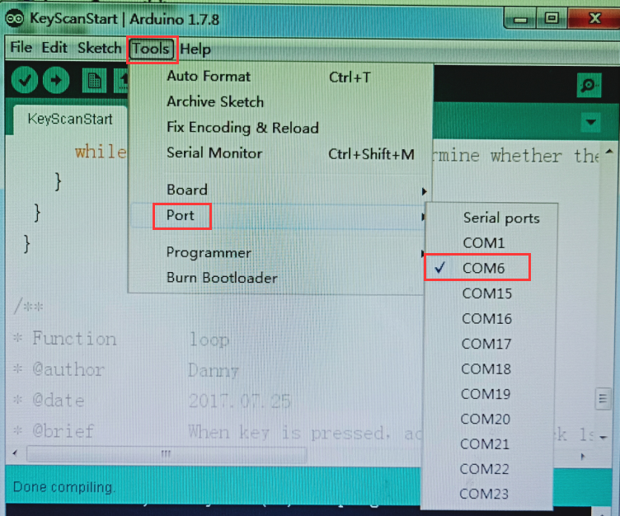

3.After the selection is completed, you need to click “**→**”under the menu bar to upload the code to the Arduino UNO board. When the word “**Done uploading**” appears in the lower left corner, the code has been successfully uploaded to the Arduino UNO board, as shown in the figure below.

